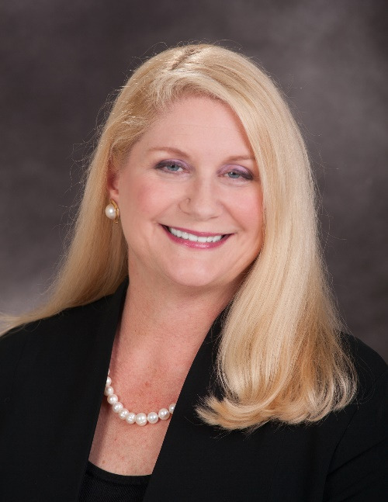
Elizabeth Link has been a professional Mediator and Arbitrator for over 15 years, specializing in employment, business, and real estate disputes, practicing throughout Kentucky, California, and the United States. Prior to becoming a mediator, she was a civil litigation attorney for 20 years. She is the CEO and Founder of the Center for Conflict Resolution and Leadership where she is a Conflict Coach and Consultant, a Conflict Resolution and Leadership Skills trainer, and Retreat Facilitator. Elizabeth is also an Adjunct Law Professor at UC Berkeley Law School and UC Hastings College of the Law in San Francisco, where she teaches classes on mediation and negotiation. She earned her Juris Doctorate degree from the George Washington University Law School in Washington, D.C.

